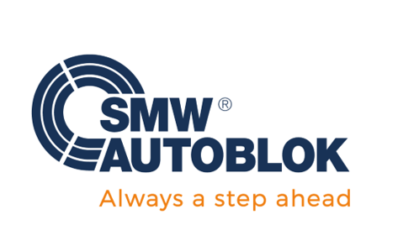

**November 2, 2022**

**FOR IMMEDIATE RELEASE CONTACT:** Tori Murray

Ph: 847-721-9032  
 Murray Marketing Solutions, Ltd.

Email: [pottermurray@mac.com](mailto:pottermurray@mac.com)

**Increase Spindle Uptime and Reduce Setup Time with Custom Setup Stations**

**Wheeling, IL** – SMW Autoblok, a world leader in the design and manufacture of rotational chucks, stationary workholding, tooling and custom engineered solutions for the machine tool industry, introduces the Series 800 and 1200 custom Setup Stations that offer complete interchangeability across all machines with a common interface. Use Setup stations in a variety of standard and custom machining applications including turning, 5-axis machining, milling, inspection, and finishing operations.

With new custom Setup Stations featuring a variety of Zero Point stationary workholding systems, customers can quickly create a common interface from machine-to-machine using our offline Setup Station and the same Zero Point configuration on all machines.

Once the part is set, Setup Stations allow users to hold and locate the part and move the APS fixture from machine-to-machine with extremely high repeatability and zero setup time since there is a common interface across all machines. This is especially important due to the customization that is often required for special applications including automation.

(more)

Custom Setup Stations

(Page 2)

Available in diameters of 800 mm and 1200 mm (custom sizes per application requirements), the series 800 offers a maximum swing of 1100 mm and max weight of 1500 kg for the fixture plate and components. The series 1200 features a maximum swing of 1700 mm and weight of 2000 kg. Both models feature an RPM of 0 to 3 and are available in voltages of 220, 240, 380 and 480.

The additional features and benefits of the APS and custom setup tables include:

* Repeatability within 0.005 mm
* Handset jogging function with 3 speed selections
* Safety pull cord
* Eliminates on-machine setup
* Dramatically increases machine productivity by loading and qualifying components offline

For more information on custom Setup Stations please contact:

SMW Autoblok

847-215-0591   
Walter Claerhout

Stationary Workholding Product Manager

[info@smwautoblok.com](mailto:info@smwautoblok.com)

**ABOUT SMW AUTOBLOK**

Established in 1981, SMW Autoblok is at the forefront of engineering and manufacturing of the highest quality workholding, clamping, gripping systems and tooling solutions. With the most comprehensive line of chucks, cylinders, mandrels, steady rests and live tools in the world, SMW Autoblok is proud to offer these products along with superior service and support. Our production facilities are in Caprie-Italy, Meckenbeuren-Germany, Wheeling IL-USA, Shanghai-China and Pune-India. The global corporate organization, SMW Autoblok, achieved sustained global growth by providing a superior level of customer service and technical support for our application driven product line. Now our group is a global corporate established in China, India, Russia, Spain, Mexico, Taiwan and Czech Republic. With the addition of Mario Pinto and OML the group is now unmatched worldwide.

###