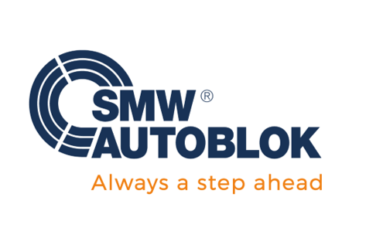

**Date: December 19, 2022**

**FOR IMMEDIATE RELEASE PRESS CONTACT:** Tori Murray

Ph: 847-721-9032

Murray Marketing Solutions, Ltd.

Email: [pottermurray@mac.com](mailto:pottermurray@mac.com)

**New Electronic ZeroAct E-motion Features Mechatronic Zero Point Actuation**

SMW Autoblok, a world leader in the design and manufacture of rotational chucks, stationary workholding, tooling and engineered solutions for the machine tool industry, introduces the electronic ZeroAct E-motion automatic positioning system featuring Zero Point clamping used in a variety of machining applications including milling, inspection, finishing, clean room operations and 3D printing.

Ideal for Industry 4.0, ZeroAct e-motion features wireless connectivity and data transfer, and fully automates manufacturing processes using a 24V power supply that operates with a built-in electro-motor. In addition, integrated electronic sensor technology provides contact-free part detection and safety for missing or misaligned parts.

With an ultralow profile of 48 mm and extremely flat design, ZeroAct E-motion is ideal for any Zero Point application especially those where a large Z-axis travel of the spindle is critical for application success.

(more)

ZeroAct e-motion

(Page 2)

The modular ZeroAct E-motion system, with a compact size of 150 x 150 mm, provides a repeat accuracy of < 5 µm and holding force of 35, 50, or 75 kN depending on thread of clamping pin.

The electronic ZeroAct E-motion is part of the comprehensive lineup of plug & play mechatronic workholding products including chucks and stationary workholding for intelligent part holding.

Download the ZeroAct E-motion brochure here: <https://bit.ly/3W2F0cY>

Visit SMW Autoblok’s website for additional information on premium workholding and tooling products at: <https://www.smwautoblok.com/us/en/>, or call: 847-215-0591 for additional information.

**ABOUT SMW AUTOBLOK**

Established in 1981, SMW Autoblok is at the forefront of engineering and manufacturing of the highest quality workholding, clamping, gripping systems and tooling solutions. With the most comprehensive line of chucks, cylinders, mandrels, steady rests and live tools in the world, SMW Autoblok is proud to offer these products along with superior service and support. Our production facilities are in Caprie-Italy, Meckenbeuren-Germany, Wheeling IL-USA, Shanghai-China and Pune-India. The global corporate organization, SMW Autoblok, achieved sustained global growth by providing a superior level of customer service and technical support for our application driven product line. Now our group is a global corporate established in China, India, Russia, Spain, Mexico, Taiwan and Czech Republic. With the addition of Mario Pinto and OML the group is now unmatched worldwide.

###